Hybrid Markup

📌 Definition:
# Source: AI Source: Provided by: [Data Path: Persons Table -> ID Column: 1, Name_En Column: Motasem Essam] -> From: [ChatGPT] on [12/9/2025]
Hybrid markup combines more than one type of markup (semantic + presentational + procedural) in a single system.

🧠 Simple idea:
# Source: AI Source: Provided by: [Data Path: Persons Table -> ID Column: 1, Name_En Column: Motasem Essam] -> From: [ChatGPT] on [12/9/2025]
Hybrid = “All-in-one” (structure + style + behavior) 🧠🎨⚙️

🔍 Key characteristics:
# Source: AI Source: Provided by: [Data Path: Persons Table -> ID Column: 1, Name_En Column: Motasem Essam] -> From: [ChatGPT] on [12/9/2025]
- 🔗 Mixes structure, styling, and logic
- 🌐 Often used in modern web development
- ⚙️ Can include HTML + CSS + scripting (JavaScript)
- 📱 Supports interactive and dynamic content

📌 Examples:
# Source: AI Source: Provided by: [Data Path: Persons Table -> ID Column: 1, Name_En Column: Motasem Essam] -> From: [ChatGPT] on [12/9/2025]
🌐 HTML + CSS + JavaScript together
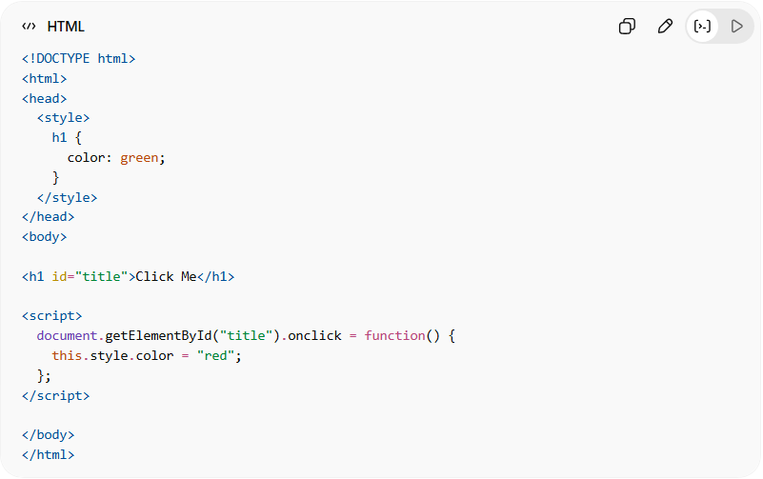
<!DOCTYPE html>
<html>
<head>
<style>
h1 {
color: green;
}
</style>
</head>
<body>

<h1 id="title">Click Me</h1>

<script>
document.getElementById("title").onclick = function() {
this.style.color = "red";
};
</script>

</body>
</html>
👉 This combines:
- 🏷️ HTML → structure
- 🎨 CSS → styling
- ⚙️ JavaScript → behavior

🧩 Another example (web apps):
# Source: AI Source: Provided by: [Data Path: Persons Table -> ID Column: 1, Name_En Column: Motasem Essam] -> From: [ChatGPT] on [12/9/2025]
- React / Angular apps
- Templates with embedded logic

🆚 Hybrid vs Other Types
# Source: AI Source: Provided by: [Data Path: Persons Table -> ID Column: 1, Name_En Column: Motasem Essam] -> From: [ChatGPT] on [12/9/2025]
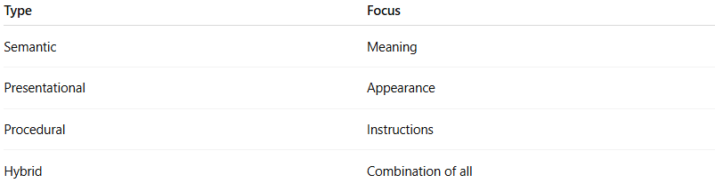
Type | Focus
Semantic | Meaning
Presentational | Appearance
Procedural | Instructions
Hybrid | Combination of all

🎯 Summary:
# Source: AI Source: Provided by: [Data Path: Persons Table -> ID Column: 1, Name_En Column: Motasem Essam] -> From: [ChatGPT] on [12/9/2025]
Hybrid markup combines multiple markup styles into one system, allowing structure, styling, and behavior to work together seamlessly.

